**SMART WATER MANAGEMENT**

**IOT Phase 2**

**REG NO : 610821106026**

**NAME: Gopika.P**

**Providing machine learning algorithms to analyze water consumption patterns and conservation suggestions:**

* Gather historical water consumption data, which can include meter readings or smart meter data, time-stamped consumption records, and any other relevant information.
* Clean and preprocess the data to handle missing values, outliers, and inconsistencies.
* Extract meaningful features from the data. For water consumption, these could include average daily usage, seasonal variations, peak usage times, and historical trends.
* Choose appropriate machine learning algorithms based on the nature of the problem.

**Water Detection Algorithm:**

* The algorithm detects the possible existence of a water leak considering four scenarios, for this it takes the input parameters:
* Device ID
* User ID
* Time T2
* Consumption In T2
* The Location
* Scenario A verifies if the consumption received has a negative value or the total consumption accumulated in the last 24 h has a negative trend; This could be due to failures in the smart meters when capturing consumption.
* Scenario B verifies if there is a continuous flow of water consumption in the last 24 h, since there was no consumption at any zero time, which is highly unlikely for normal consumption.
* Scenario C verifies if there is a high consumption outside its historical behavior.

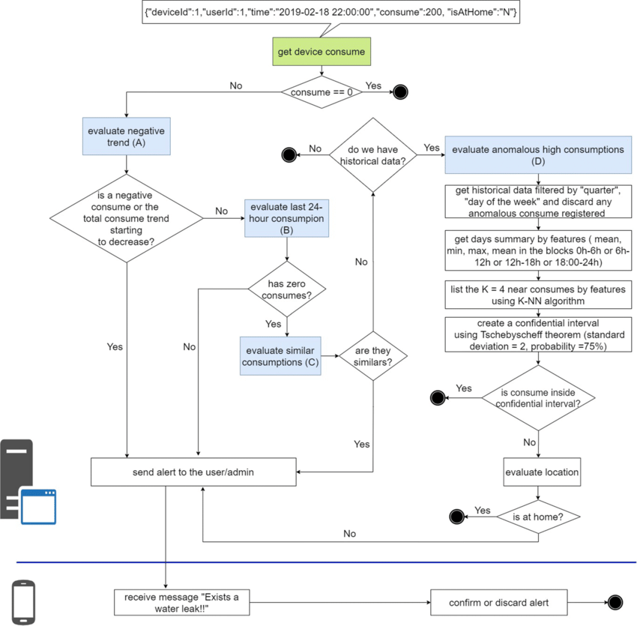**Water leak detection algorithm:**